University Of Engineering and Technology, Lahore
Computer Engineering Department

Course Name: Programming Fundamentals | Course Code: CMPE-112L
Assignment Type: Lab Tasks | Dated: 18-05-2026
Semester: 1st | Session: Spring
Lab/Project/Assignment #: 11 | CLOs to be covered: CLO 4
Lab Title: Exception Handling | Teacher Name: Hafiz Muhammad Mubashar
Lab Evaluation:

CLO1 | Apply appropriate programming techniques to create executable programs to solve well defined problems
 | Level1 | Level2 | Level3 | Level4 | Level5 | Level6
(5)
Total |  |  |  |  |  | /5
Rubrics for Current Lab Evaluation
Scale | Marks | Level | Rubric
Excellent | 5 | L1 | Submitted all lab tasks, BONUS task, have good understanding.
Very Good | 4 | L2 | Submitted the lab tasks but have good understanding
Good | 3 | L3 | Submitted the lab tasks but have weak understanding.
Basic | 2 | L4 | Submitted the lab tasks but have no understanding.
Barely Acceptable | 1 | L5 | Submitted only one lab task.
Not Acceptable | 0 | L6 | Did not attempt
LAB No 11
Lab Goals/Objectives:
Basically this lab will focus on students skills on exception handling. So that they can use it smoothly in their lenghty codes.

Equipment Required:
Py Charm, Vs code, Laptop or Computer.

Theory:
Ecception Handling
If “--name-- == --main--”
main( )

Lab Work:

Task 1: Using try and except in code.

Result:

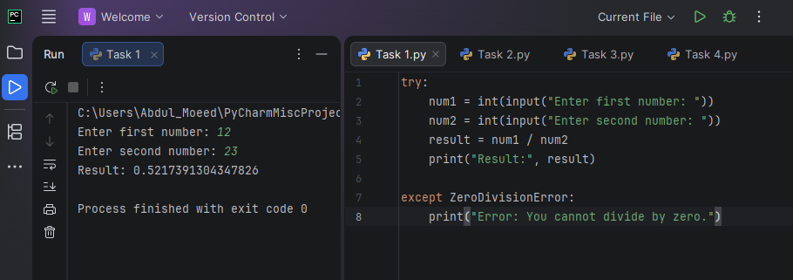

Task 2: Finding age.

Result:
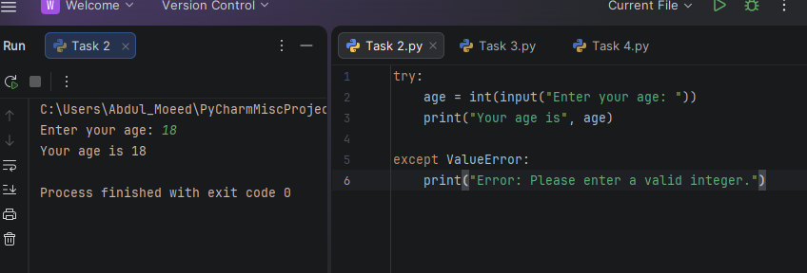

Task 3: File exists or not.

Result:
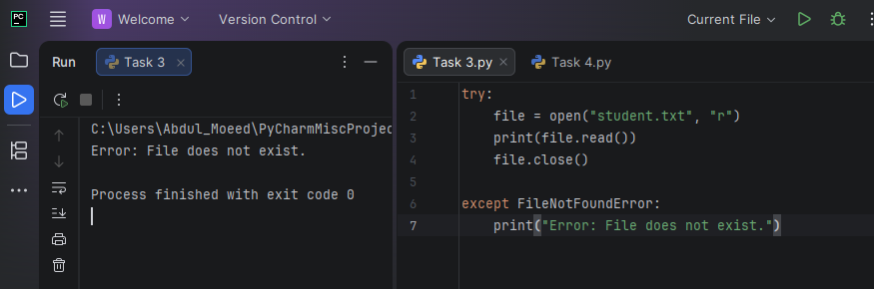

Task 4: A larger one.
Result:
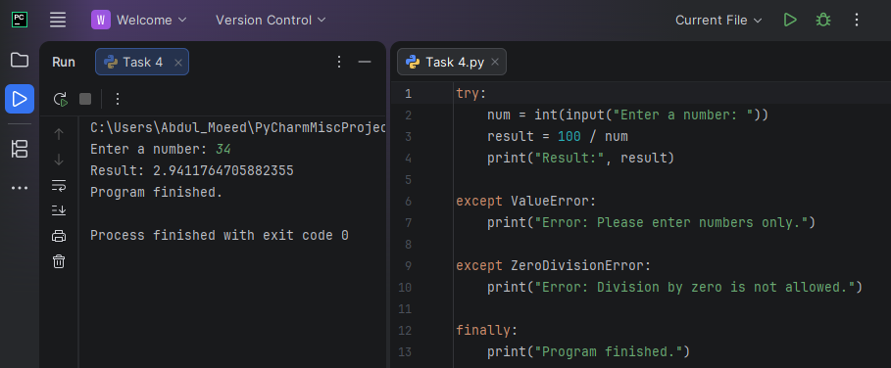

Conclusions:

We have learned how to use try and except in our code.

